Mini Project Using Servlet and JSP

Objective: Employee Management System. In this Assignments you have to Create new dept and add employee in dept and view employee dept wise and search employee dept wise

Front End : html,CSS , bootstrap,JS and JSP (form should be mobile responsive)
Backend: Servlet , JDBC
Database : MYSQL
Tool: Eclipse
Tables

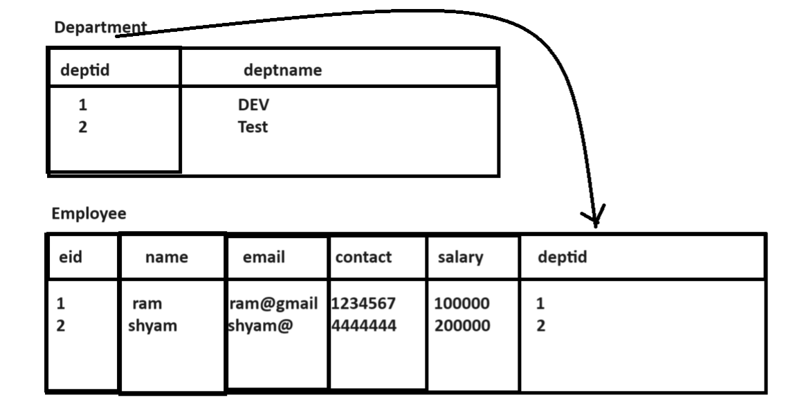

Tables
Dept
Column | Datatype | Constraints
Deptid | Int(5) | Primary key auto_increment
Name | Varchar(200) | Not null unique

Column name | Datatype | Constraints
Eid | Int(5) | Primary key auto_increment
Name | Varchar(200) | Not null
Email | Varchar(200) | Not null unique
Contact | Varchar(200) | Not null unique
Salary | Int(5) | Default 10000
Deptid | Int(5) | Foreign key on delete cascade on delete update

Coding Architecture
View – model - controller -- service ----repository --- database

Forms
Nav.html

When user click on Add Dept link then following form should be navigate
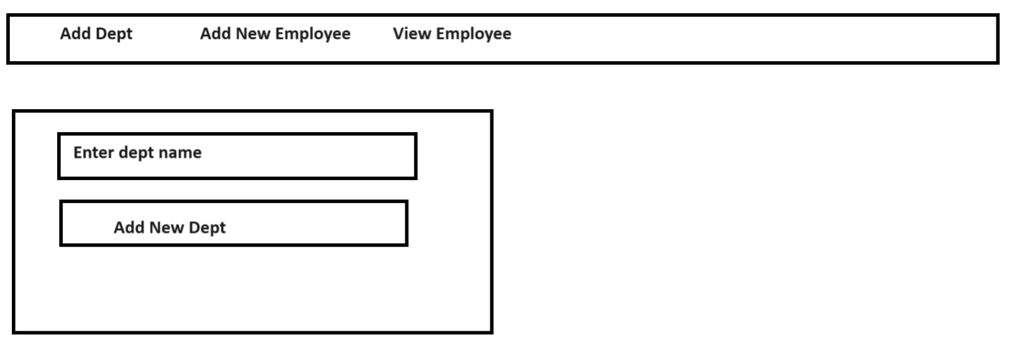
When user click on Add New Dept button then dept name should be save in Dept table and generate dept id automatically
Rules:
- Dept name must be save as capital in database means when Dept name present in table then show message dept present in database table.
- Dept name should save duplicate
- Any digit or special symbol should not be accepted in dept name
When user click on Add New Employee menu then following form should be visible
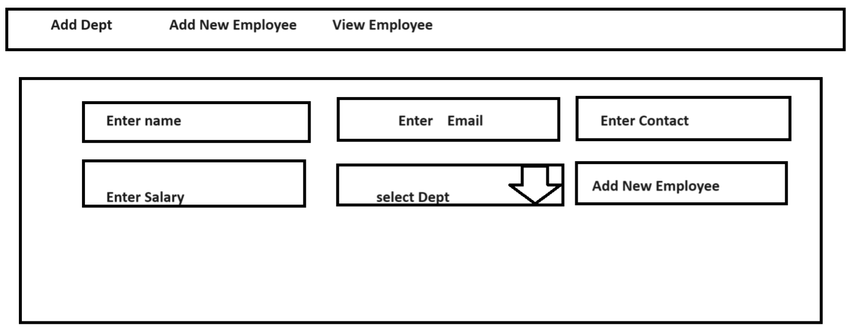
If we think about above form you have to fetch all dept from dept table and display in Add New Employee form drop down box and when user click on Add New Employee button then you have to store name,email,contact and salary in Employee table and fetch dept id from dept table as per dept selected in dropdown and store in employee table as foreign key internally
Rules
- Name must be contain only alphabet not other symbol or digit except space.
- Perform email validation
- Contact length must be 10 digit and not allow any alphabet or special symbol in contact
- Salary must be contain only digit not other symbol
- If all field properly fill and when user click on Add New Button then form must be submit to server otherwise not
When user click on View All Employee menu then your page should look like as
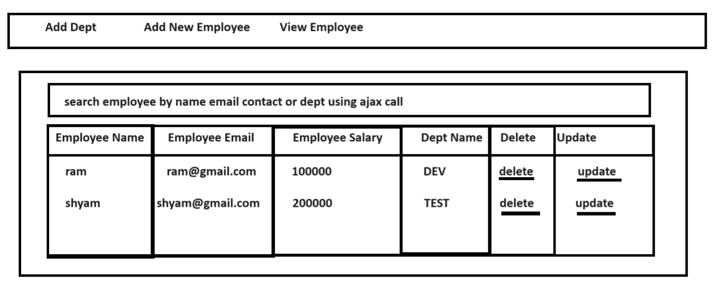
If we think about above page then you have to perform join between employee and dept table and fetch data from database table and display on web page and when user input name or email or contact in textbox then data must be search in join which we perform between employee and dept table and display on web page here you have to perform AJAX Call

